**05 Laboratory Exercise (Create a gameplay mode for microgames)**

* **Beginning of the game**. In this game, the player must hit all the killer enemies and find the items that will help them survive. There are various rooms in this game, and each room may have different killer enemies as well as items for survival.

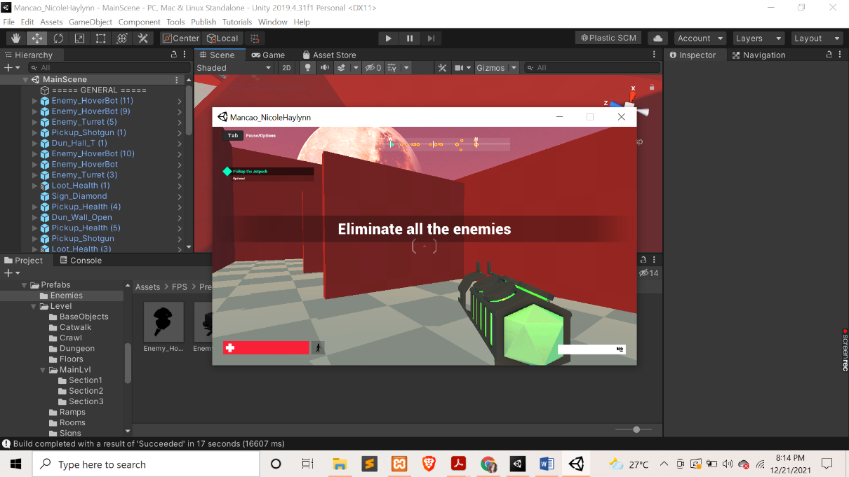

* **Execute all the enemies.** The player’s primary goal in this game is to eliminate or execute all the enemies using their own built-in weapons. They can also get another life (life steal) when they successfully hit the killer enemy.

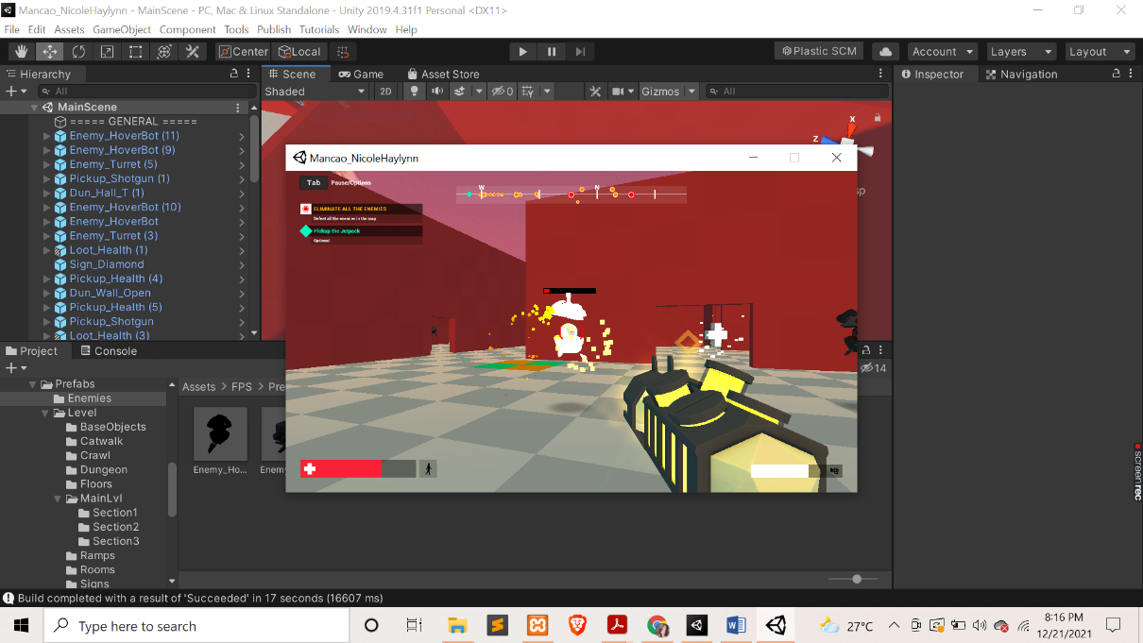

* **Items/weapons for survival**. The player must roam around and find the items in order to help them survive and kill the powered monster.

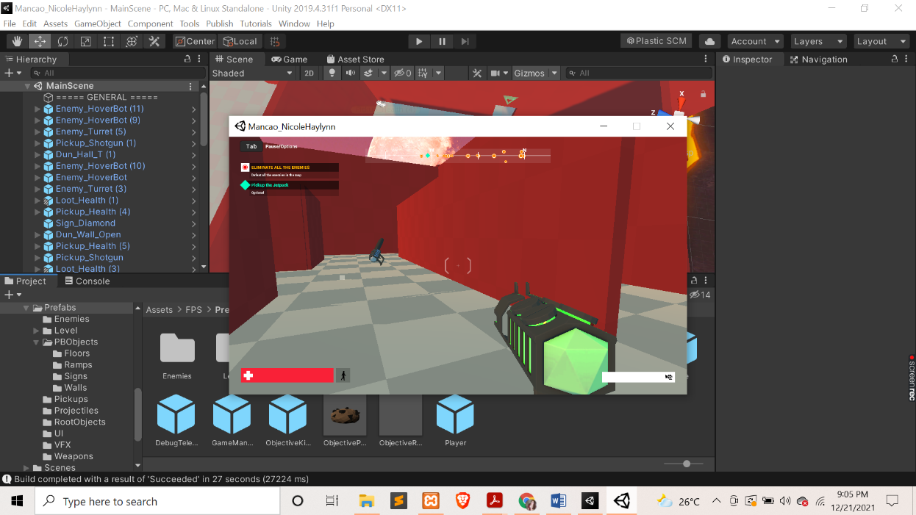

* 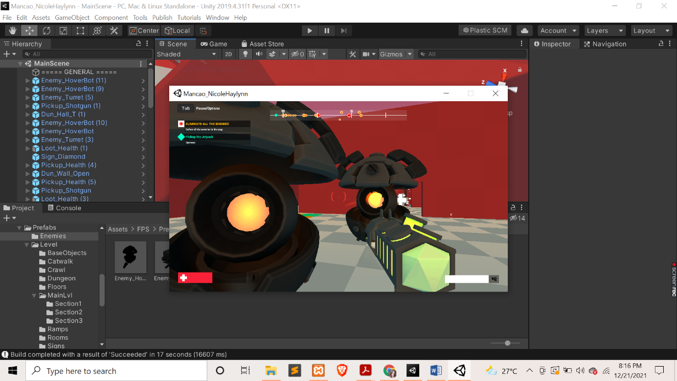When the enemies are chasing you, try to avoid and kill them right away.
* **Beware of attacks**. The player must be vigilant when the enemy is trying to attack them. They can be slain by these attacks and lose the game.

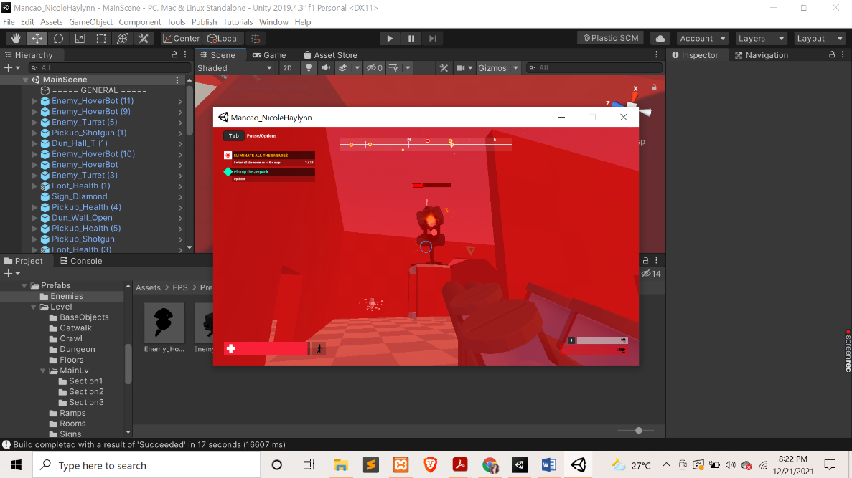

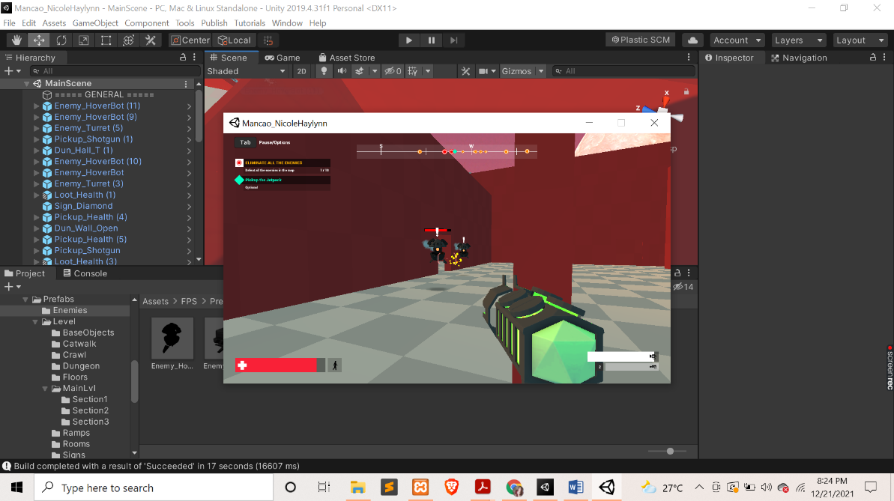

* 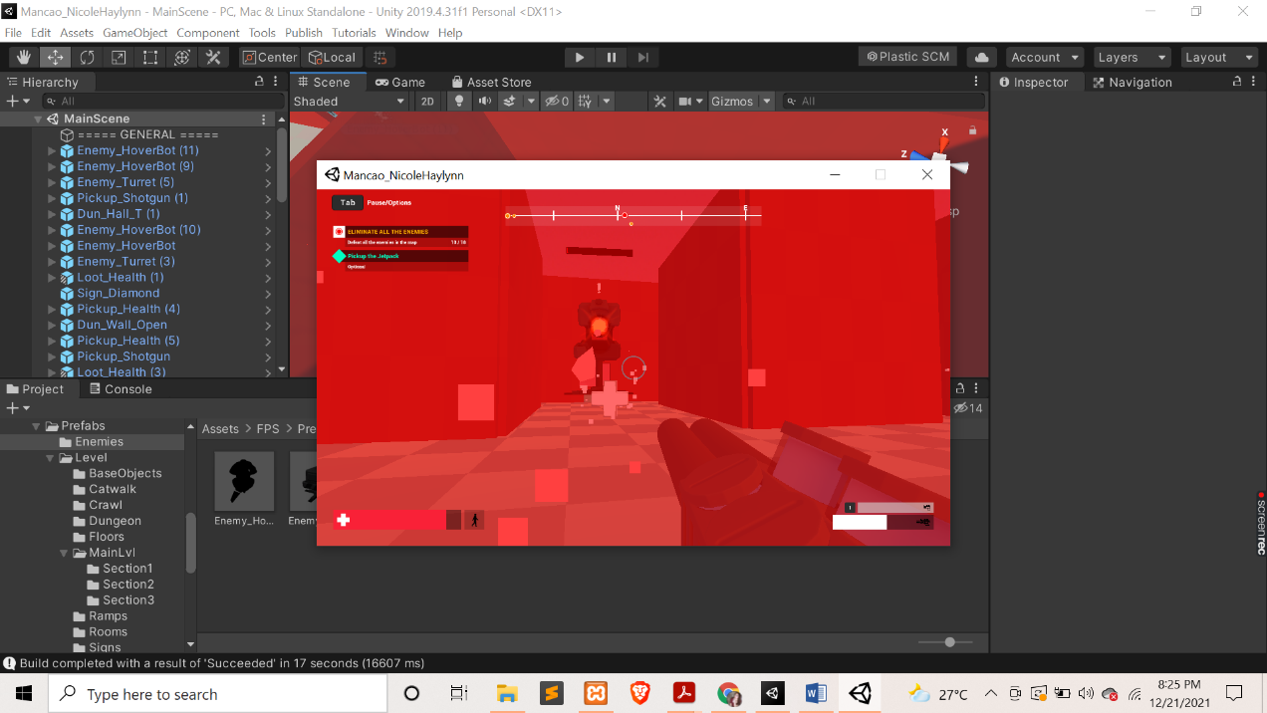**Clear wave**. The key to victory is to ensure that all enemies are executed. The player can gain points if they win the game. The points will depend on the player’s performance during the game.